Lab 2: Build and test a Wired (Ethernet) Network
Mark 20

Things that you will need to know or learn:
- The correct cable type for connecting network devices (from pre-lab cable).
- Identification and purpose of the Linksys E2500 Ethernet ports, Internet port (yellow port), power port, buttons (two), power light, Ethernet port lights, and Internet port light (from pre-lab, lecture-Linksys).
- How to create an Ethernet (wired) network with the Linksys Router (from in-lab-Linksys-cables).
- Describe the network components (switch, router) (from lecture).
- What a valid IPv4 address looks like; what a valid subnet mask looks like (from lectures and pre-lab)
- How to determine your IPv4 address and subnet masks using ipconfig (from lectures and pre-lab)
- How to determine your Default Gateway address (from lectures and pre-lab)
- How to verify basic network connectivity using ping (from lectures and in-lab)
- How to copy text from the command line window (aka DOS box)
- How to use Wireshark to see actual network traffic (from pre-lab Wireshark)

What you need to submit and when:
- Answers to the questions should be RED. (other colors deduct 2 marks)
- Demo your lab 2 in class and answer some questions to your lab instructor. (No submission on BS)

Required Equipment/Software:
- Network cables, Linksys (E2500) router
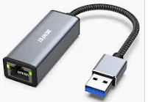
- RJ45 adapter to USB (for laptops without RJ45 port)
- Wireshark installed and working

References and Resources: (Pre-lab 2) (Bright space)
- How to IP in Windows
- How to Wireshark
- How to Cable
- Linksys E2500 router

Cable Types
- You will be using 2 types of cables: straight-through and crossover.
- A straight-through cable is used for connecting different types of devices (e.g., PC to switch, router to switch)
- A crossover cable connects “like” devices (e.g., PC to PC, PC to router, server to router, router to router, switch to switch.
- Rollover cable (not within the scope of this course) is a Cisco proprietary cable used to connect from a Console port.
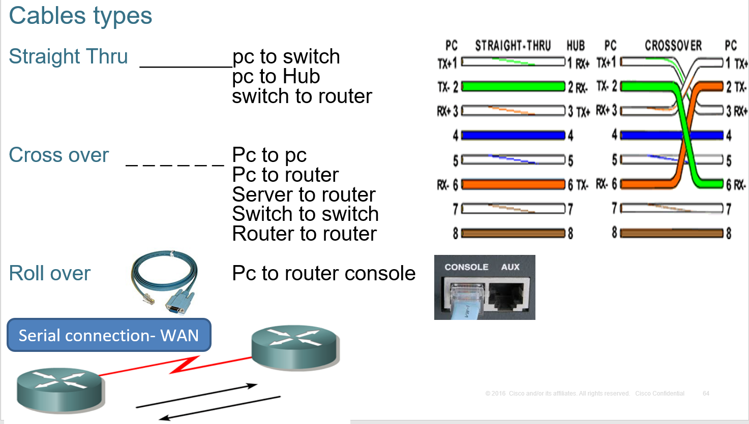

Task 0: Preparation
1-Disable the Wireless Network Interface, VMware (Virtual machine), Anti-virus, and Windows firewall defender of your laptop computer. Your only connection to the network connection must be via the Ethernet (wired) interface.
2-Do not start until you have completed ALL steps in this task.

Task 1: Build a Network with Linksys Router
In this task, you will build and test a network of two physical devices: your laptop and a Linksys router ( DHCP). This is the network topology on which we will build in subsequent labs.
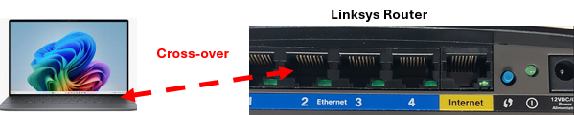

- Do not start Task 1 until you have completed all Task 0 steps.
- Obtain a Linksys router, power adapter, power adapter, straight through, and crossover (orange or yellow) cables from your instructor.
- Power on your Linksys router and wait until the router’s green power indicator LED is on steadily before proceeding to the next step. Note that during boot-up, router reset, and firmware upgrades, the power indicator light flashes slowly. Consult the reference documentation for an explanation of the meaning of other power indicator states.
- Reset the router back to factory defaults. (press the reset button underneath of the router)
- Ensure your Laptop’s Ethernet network adapter (wired) is configured to obtain its IPv4 address automatically via Dynamic Host Configuration Protocol (read: How to IP in Windows 11)
- Using the correct cable connect your laptop’s Ethernet port to any of your Linksys router’s switches’ Ethernet ports. (1,2,3,4). Your laptop will attempt to obtain an IPv4 address from your Linksys’s DHCP router. Please be patient as this process may take up to 60 seconds.
What is the correct cable type to connect your laptop to the router’s Ethernet port? (1 mark)

Cross-over Cable

- Ensure that the green light corresponding to the Linksys’s Ethernet port you connected into is flashing. This is an indication that there is network activity on the port.
- At the Windows command prompt (CMD), type ipconfig /all. What is the IPv4 address subnet mask and default gateway that has been assigned to your laptop Ethernet port by Linksys’s DHCP server (Linksys router)? (3 mark)

IPv4 address: 192.168.1.2
Subnet Mask: 255.255.255.0
Default Gateway: 10.25.10.1

NOTE:
The IPv4 address that should be assigned to your Ethernet Network adapter is of the form: 192.168.1.x. (class C). Any other IP address like 169. x.y.z (link Local) is an indication of a problem or wrong IP address.
That means your PC did not get an IP address from the DHCP (Linksys router).
- Ping your laptop's default gateway address (router IP address) to verify your laptop connectivity (layer 3) to the router. At the Windows command prompt, type the following command:
ping default gateway address (router interface)
A successful ping will look like this: Example:
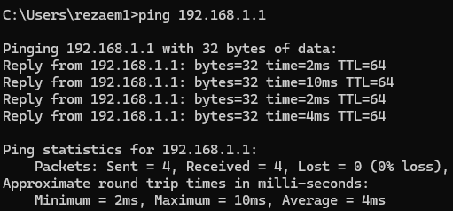

Task 2: Configure Laptop with IPv4 Static Address

In this task, you will implement a static IP address manually to your laptop and ping your default gateway
- Assign the following IPV4 address to your Ethernet (wired) network adapter manually: (your laptop)
Go to Windows logo+ R Runncpa.cplright click on Ethernet properties Internet IPv4
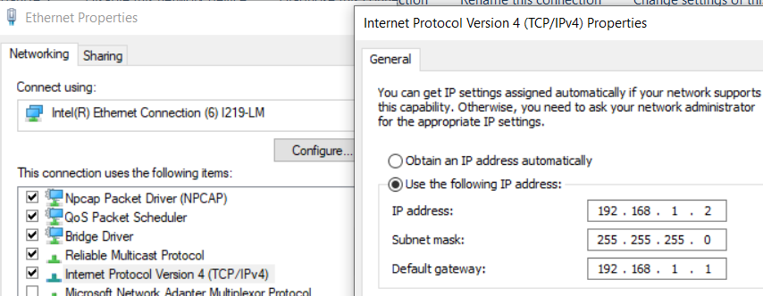

IPV4 address: 192.168.1.X where x is the router Ethernet port (1,2,3,4) number your laptop is connected to.
Subnet mask: 255.255.255.0
Default Gateway: Enter the value noted from task 1.
- What command do you use to verify that the IP address assigned in the previous step has been successfully assigned to your Ethernet (wired) adapter? (1 mark) ipconfig /all

- What command do you use to confirm that your laptop is connected to the network? (1 mark)

ping

- Go back to the laptop and modify your laptop’s Ethernet network adapter’s configuration to automatically obtain an IPv4 address via DHCP. Disconnect your laptop from the Linksys router now.

Task 3: Configure Laptop with Dynamic Address (Red Network)
Now connect your laptop to the Red port on your desk. Your PC should get an IP address automatically from the remote server (server- Red port). You are connected to another DHCP server (remote server). You will connect your laptop to the Internal Lab Network. Read the “How to IP in Windows -pre-lab” document for more information.
Note: your laptop should have an IP address starting with 172.16.X.X. Any other number like 169.16.X.X (Link-Local) you are getting is the wrong IP address and needs troubleshooting. (How: reset your laptop if it is needed)
- What command do you use to verify that your laptop got an IP address from DHCP?
(1 mark) ipconfig /all

- What command do you use to confirm that your laptop is connected to the network? (1 mark)
ping

Task 4: Use Wireshark to capture network traffic
- Prepare Wireshark to capture network traffic on your Ethernet adapter:
- Open Wireshark (run as administer)
- From Wireshark’s menu, click Capture –> Options.
- From the Capture Options window, highlight and select the Ethernet adapter (NIC) with the correct IP address. BE SURE TO SELECT THE CORRECT ADAPTER!
- Choose the entry of your Ethernet adapter check the Number under Buffer and increase it to 10. (double-click on the number). This change will ensure the capture buffer is large enough to not discard the packets of interest should there be a lot of traffic on the wire.
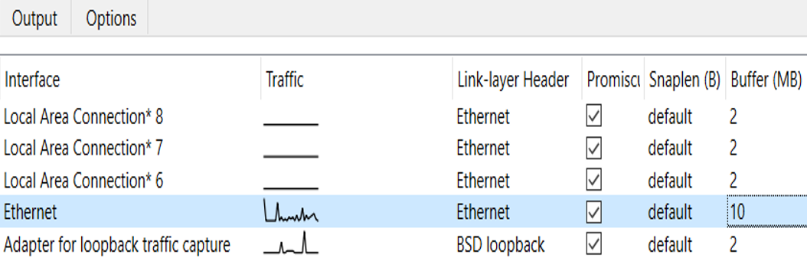

What is your laptop IP address now? (3 mark)
IP address: 172.16.254.107
Subnet mask: 255.255.0.0
Default Gateway: 172.16.255.254
- Click Start (on the Capture Options window) to begin capturing network traffic.
- Ping your DG (172.16.X.X). You should see 4 echo and 4 replies (TTL) in CMD. Stop the WS.
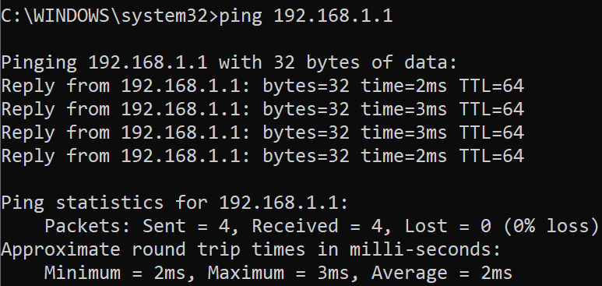

In WS, you should see 4 echo requests and 4 echo replies

- Examine captured traffic in WS, noting the three windows, each one with increasing amounts of detail. In Wireshark’s top pane, you should count at least eight lines that have ICMP in the protocol column.
What is ICMP? (1 mark)
Internet Control Message Protocol

- What other traffic, if any, was captured by Wireshark?
DNS, ARP, DTP

- You can filter specific “packets” in your WS. Type “ICMP” in the filter box ( ) and click apply to view just your “ping” traffic.

- Now in WS, open the filter (ICMP) and click on the white arrow ( on the right side of the screen. WS goes back to the previous screen. This time filter with the ARP to see the MAC addresses of the devices. (2 mark)

What is the MAC address of the source? 74:d4:dd:60:d9:88
What is the MAC address of destination ff:ff:ff:ff:ff:ff
What is ARP?
Address Resolution Protocol (1 mark)

Insert a snapshot of ARP here (1 mark)
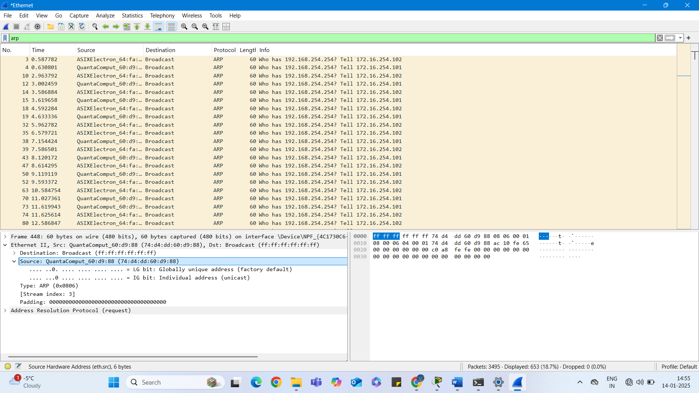
- Click clear after examining the results as simply erasing the field content with the erase or delete keys will NOT clear the filter. Using filters in Wireshark can help you find packets of interest.
- What ping message is sent from your laptop to the default gateway? (1 mark).
The source IP address will be the address of your laptop, and the destination IP address will be the address of the gateway.
74 Echo (ping) replay id=0x0001, seq=25/6400, ttl=225

- What type of ping message is sent by the default gateway in reply to your laptop’s ping? This time the source IP address will be the gateway’s address. (3 mark)
  - What is source IP address 172.16.255.254
  - What is destination IP address 172.16.254.93
  - What is Info in the Wireshark?
74 Echo (ping) replay id=0x0001, seq=25/6400, ttl=225

- Save the Wireshark capture for later examination in class. Save to a file named Task4-wireshark.

Task 5: Clean up and Submission
  - Re-enable your Wireless Network and confirm you can access the College.
  - Demo your lab 2 in class to your lab instructor. (No submission on BS)

